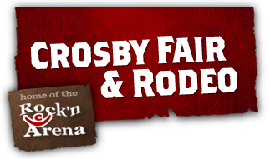
4th Annual Golf Tournament Fundraiser
“Supporting Youth & Education”

4-Man Scramble Format
Friday May 18th, 2018
Lunch Served 10:30 - 11:30 am
Shotgun Start @ 12:00 pm

16401 Country Club Drive
Crosby, TX 77532 - 281-328-3576

$400 / Team - $100 / Golfer
$100 Hole Sponsors
$500 Gold Sponsor (Includes Banner & Plaque)
$1000 Platinum Sponsor (Includes Banner, Plaque & Team)
Longest Drive & Closest to the Pin Contest,
Mulligans, Door Prizes and More…

Team

Player 1: _______________________________________________

Player 2: _______________________________________________

Player 3: _______________________________________________

Player 4: _______________________________________________

Sponsor: ___________________________________________________________

Contacts: Mike Niemtschk (832-631-0719) Jared Prescott (713-305-4009)

Make Checks Payable to: Crosby Fair & Rodeo

